**Lab practical 06**

**COA**

**Question:**

**Write a program in assembly language to take a single-digit integer from the user**

**and print it on the screen.**

**Code:**

**ORG 100h ; Origin for COM file format (starts at 100h)**

**; Display message: "Enter a single digit: "**

**MOV AH, 09h ; Function 09h is used to display a string**

**MOV DX, OFFSET msg_input ; Load the address of the input message into DX**

**INT 21h ; DOS interrupt to display message**

**; Read single character input from the user**

**MOV AH, 01h ; Function 01h is used to read a character from input**

**INT 21h ; DOS interrupt to get the character from the user**

**MOV BL, AL ; Save the input character in BL for later use**

**; Check if the entered character is a valid digit (between '0' and '9')**

**CMP AL, '0' ; Compare with '0'**

**JL InvalidInput ; If input is less than '0', it's invalid**

**CMP AL, '9' ; Compare with '9'**

**JG InvalidInput ; If input is greater than '9', it's invalid**

**; If valid digit, print the entered digit**

**; Display message: "The entered digit is: "**

**MOV AH, 09h ; Function 09h is used to display a string**

**MOV DX, OFFSET msg_output ; Load the address of the output message into DX**

**INT 21h ; DOS interrupt to display message**

**; Print the valid digit**

**MOV DL, BL ; Move the valid character from BL to DL (for printing)**

**MOV AH, 02h ; Function 02h is used to print a single character**

**INT 21h ; DOS interrupt to print the character**

**JMP EndProgram ; Jump to EndProgram to terminate successfully**

**InvalidInput:**

**; Display error message if the input is invalid (not a single-digit number)**

**MOV AH, 09h ; Function 09h is used to display a string**

**MOV DX, OFFSET msg_error ; Load the address of the error message into DX**

**INT 21h ; DOS interrupt to display error message**

**EndProgram:**

**MOV AH, 4Ch ; Function 4Ch is used to terminate the program**

**INT 21h ; DOS interrupt to exit**

**msg_input DB 'Enter a single digit: $' ; Input prompt message**

**msg_output DB 0Dh, 0Ah, 'The entered digit is: $' ; Output message with newline**

**msg_error DB 0Dh, 0Ah, 'Error: Invalid input! $' ; Error message with newline**

**END ; End of program**

**OUTPUT:**

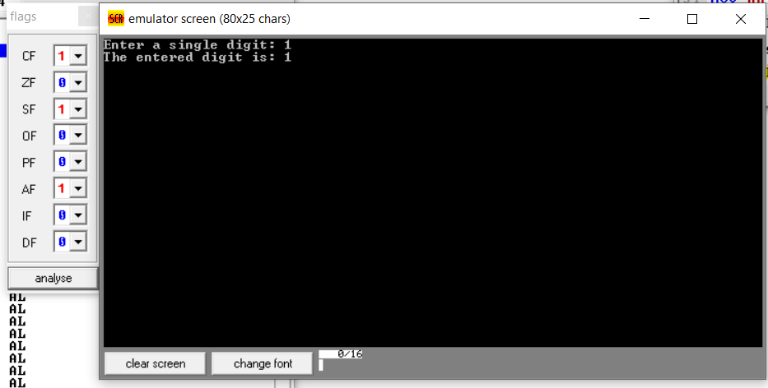

**Write a program in assembly language to take two single-digit integers from the user and print the result of subtraction on the screen.**

**CODE:**

**ORG 100h ; Origin for COM file format (starts at 100h)**

**; Display message: "Enter the first single digit: "**

**MOV AH, 09h ; Function 09h is used to display a string**

**MOV DX, OFFSET msg_input1 ; Load the address of the input message into DX**

**INT 21h ; DOS interrupt to display message**

**; Read the first single digit from the user**

**MOV AH, 01h ; Function 01h is used to read a character from input**

**INT 21h ; DOS interrupt to get the character**

**SUB AL, '0' ; Convert ASCII digit to actual number**

**MOV BL, AL ; Store the first digit in BL**

**; Display message: "Enter the second single digit: "**

**MOV AH, 09h ; Function 09h is used to display a string**

**MOV DX, OFFSET msg_input2 ; Load the address of the input message into DX**

**INT 21h ; DOS interrupt to display message**

**; Read the second single digit from the user**

**MOV AH, 01h ; Function 01h is used to read a character from input**

**INT 21h ; DOS interrupt to get the character**

**SUB AL, '0' ; Convert ASCII digit to actual number**

**MOV BH, AL ; Store the second digit in BH**

**; Subtract the second digit from the first**

**SUB BL, BH ; Subtract BH (second digit) from BL (first digit)**

**; Display message: "The result of subtraction is: "**

**MOV AH, 09h ; Function 09h is used to display a string**

**MOV DX, OFFSET msg_output ; Load the address of the output message into DX**

**INT 21h ; DOS interrupt to display the message**

**; Check if the result is negative**

**CMP BL, 0 ; Compare the result with 0**

**JGE PrintResult ; If result is >= 0, jump to print result**

**; If the result is negative, print the minus sign**

**MOV DL, '-' ; Load the minus sign into DL**

**MOV AH, 02h ; Function 02h to print a single character**

**INT 21h ; DOS interrupt to print the minus sign**

**; Convert the negative result to positive**

**NEG BL ; Negate the result to make it positive**

**PrintResult:**

**; Convert result to ASCII and print**

**ADD BL, '0' ; Convert result back to ASCII**

**MOV DL, BL ; Move result into DL for printing**

**MOV AH, 02h ; Function 02h is used to print a single character**

**INT 21h ; DOS interrupt to print the result**

**; End the program**

**MOV AH, 4Ch ; Function 4Ch is used to terminate the program**

**INT 21h ; DOS interrupt to exit**

**msg_input1 DB 'Enter the first single digit: $' ; Input prompt for first digit**

**msg_input2 DB 0Dh, 0Ah, 'Enter the second single digit: $' ; Input prompt for second digit**

**msg_output DB 0Dh, 0Ah, 'The result of subtraction is: $' ; Output message**

**END ; End of program**

**OUTPUT:**

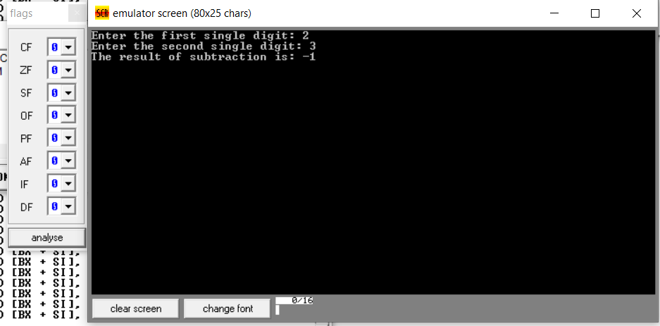

**GITHUB:**

[**https://github.com/srijachakilam15/COA/blob/main/lab%20practical%2003.docx**](https://github.com/srijachakilam15/COA/blob/main/lab%20practical%2003.docx)

s